Faculty of Electrical Engineering, Computer Science and Information Technology Osijek
Advanced Web Programming

Task 1.

Create a GraduateThesis class in PHP. This class must implement the iRadio interface (which it will have create, save and read methods) which means that the class GraduateThesis must have the methods specified. You have an example of an interface in lecture 1 in the User.php script. GraduateThesis class will have variables work_name, work_text,
work_link and identification_number.

You need to connect to the site URL https://stup.ferit.hr/zavrsni-radovi/page/$number/
using socket or cURL where $number goes from 2 to 6.

As a result, the page will return to you the HTML code that contains the information needed to create the object
classes GraduateThesis. Example code containing the required information:

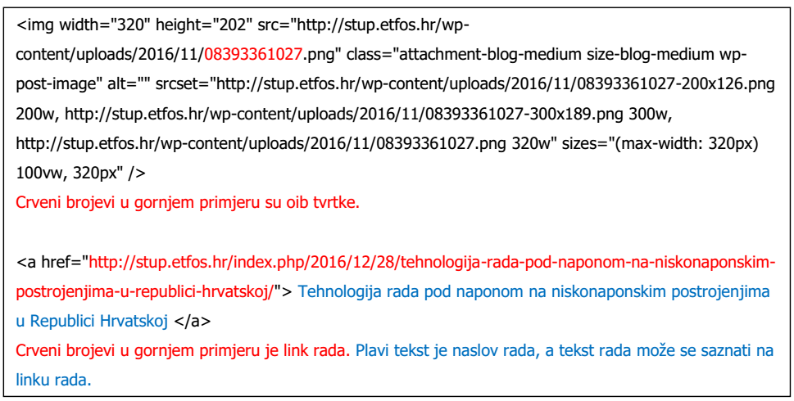

Create a new GraduateThesis class object and save the information you retrieve from the page using it
create methods. You can create your own HTML parser or use an existing one: https://simplehtmldom.sourceforge.io/

Create a MYSQL database called thesis. Inside database create a table of graduate theses with attributes equals in the GraduateThesis class (plus ID attribute). The Save Method in the GraduateThesis class should save all received theses in the table graduate_theses. The read method in the GraduateThesis class should retrieve all theses from the table graduate_theses.

